Landing, Login, And Enrollment Pages Development

Ethan Meier
CST499: Capstone for Computer Software Technology
Charmelia Butler
November 3rd, 2025

This assignment is part of the implementation phase for the online course registration system. The goal for this week was to set up the development environment, build the landing page, create the user registration page, set up the login page shell, and connect the project to a MySQL database using XAMPP. This paper explains how I ran PHP files in XAMPP, created the database and tables, and built the registration and login pages. It also shows the user data is saved in the database when someone registers. The purpose of this paper is to explain the setup process and show the pages and code that were created for the project.
To run PHP files, I installed XAMPP and started Apache and MySQL from the control panel. I placed my project folder inside the htdocs directory. Once that was done, I opened a web browser and typed http://localhost/cst499_project/. This loaded my PHP landing page. When Apache and MySQL are running, XAMPP lets PHP talk to the database, so user data can be stored and retrieved.
I opened phpMyAdmin by clicking Admin next to MySQL in XAMPP. I then created a database called cst499. Inside that database, I ran SQL command to create a user table. The table has fields for id, full name, email, phone, password, and a timestamp. This table stores all the user registration information.
The main MySQL functions used in the PHP code are insert to save user data and MySQL functions to connect to the database. I made a small database connection file called db.php that holds the connection code.
Landing Page
The landing page welcomes users and gives them links to register or log in. This is a simple HTML file named index.php.
Registration Page
The registration pages collect the username, email, phone number, and password. When users click register, the form sends the data to the database. The password is saved securely using a PHP password hash function. Once it is submitted the page confirms the registration.
Login Page
The login page has a simple placeholder message. The login logic will be completed later in the project. For now, it shows that the link works and the page loads.
Figure 1. XAMPP Control Panel Running
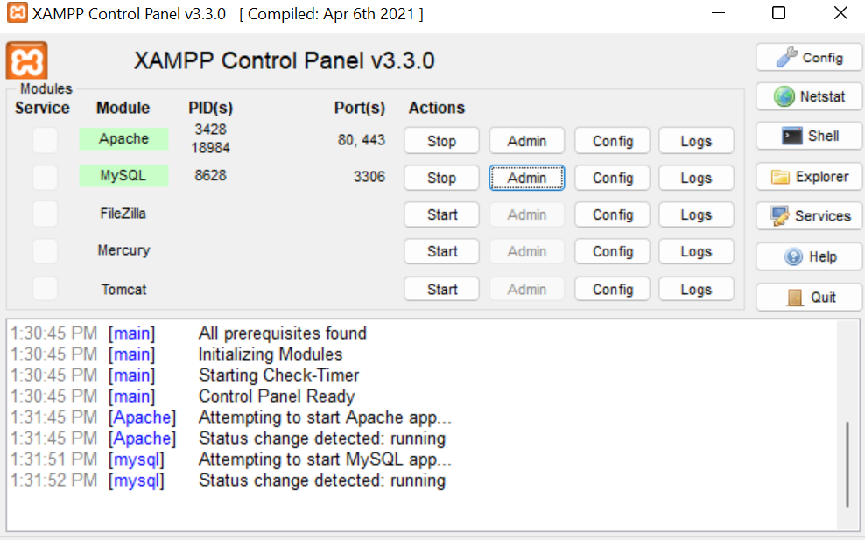

Figure 2. phpMyAdmin Database and Users Table
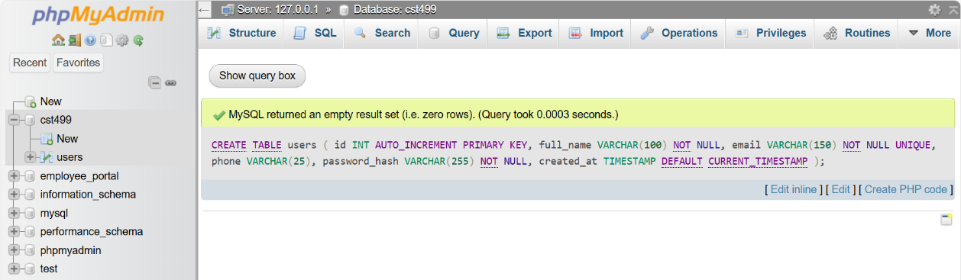

Figure 3. Landing Page Displayed in Browser


Figure 4. Registration Page Before Submitting
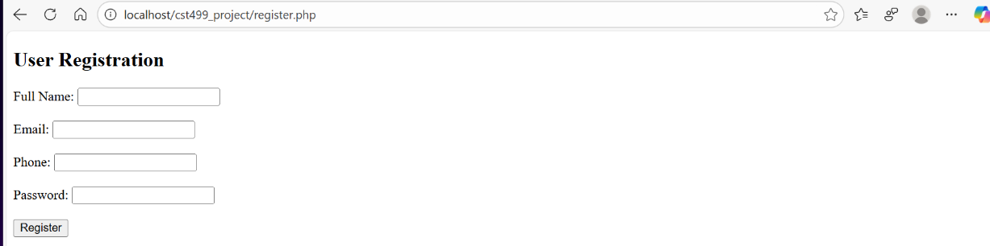

Figure 5. Registration Successful Message
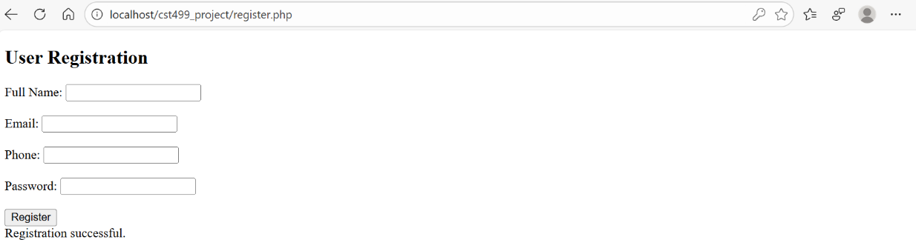

Figure 6. Database Connection File Code (db.php)
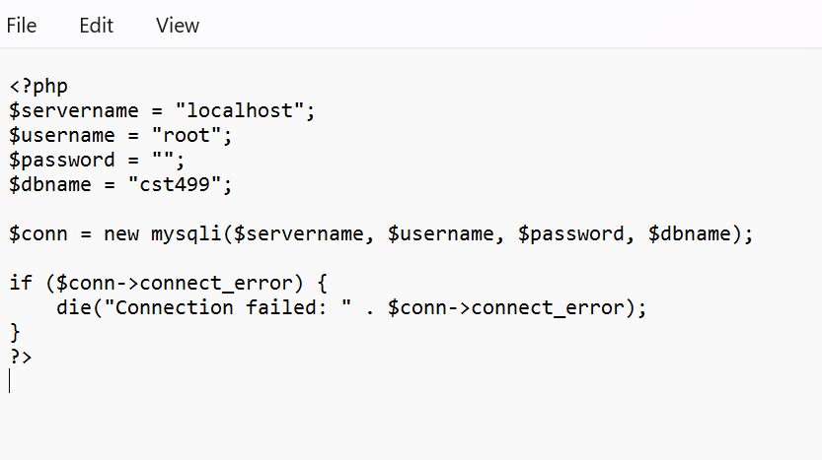

Figure 7. index.php Landing Page Code
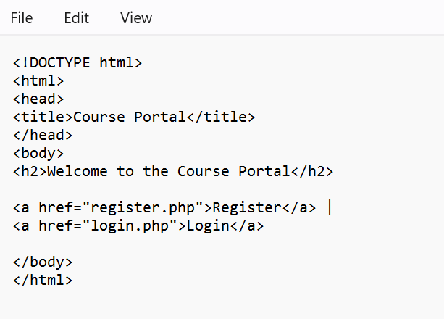

Figure 8. login.php Placeholder Page Code
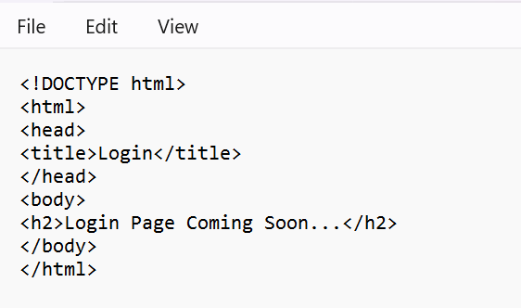

Figure 9. register.php Form and PHP Code
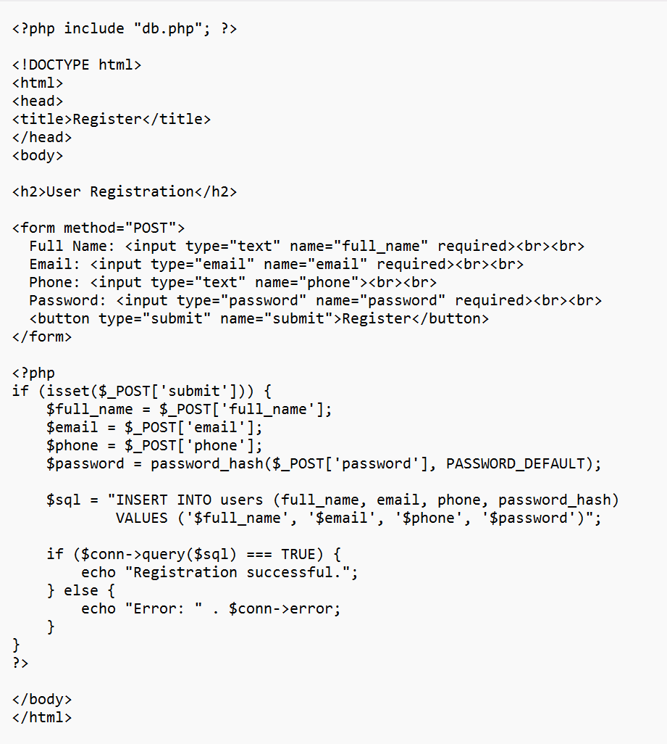

This week’s work focused on setting up the project environment and building the pages of the web application. I set up XAMPP, created the MySQL database, and built the landing, registration, and login pages. I also wrote PHP code to save user details to the database. This was an important step because it set up the core foundation for the rest of the website. Next will be the login in system and user features will continue to build.

References
Mathues, S. (2023). One step at a time: A roadmap for problem solving and making a difference. University of Arizona Global Campus.
Tsui, F., Karam, O., and Bernal, B. (2018). Essentials of software engineering (5th ed.). Jones and Bartlett Learning.

